CORNERSTONE SAINT BERNARD PUPPY PEOPLE INFORMATION

Your Name(s)_______________________________________________________

Address:__________________________________________________________________________________________________________________________________________________________________________________________________
Home Phone:_______________________ Cell Phone:______________________
Email Address:____________________________________________
Occupation:_______________________________________________
Spouse Occupation_________________________________________
Number of Children and ages:__________________________________________________________________________________________________________________________________
________________________________________________________________________________________________
Do you own_______ Rent______ your house
Type of neighborhood(city/suburbs/country etc)___________________________
Is your yard fenced____________________
Approximate size of fenced area__________________________
Will this dog be an indoor or outdoor pet?___________
Do you own other pets? Dogs____ Cats_____ Other____
Are these pets spayed/neutered_____________________________
What kind of training have you done with these other animals__________________
___________________________________________________________________
Do you plan to chain or tether this dog with and over head runner?_____
Do you plan to show this dog?____
Do you plan to breed this dog?____
Do you plan to neuter/spay this dog?_____
Have you ever given an animal to an animal shelter?_______
If so why___________________________________________________________
___________________________________________________________________
Have you ever raised a puppy?___________
Do you own a crate/do you plan to crate this puppy______________________
Where will this dog sleep?_________________________________________
Where will this dog be while your away?(work etc)______________________
_______________________________________________________________
Do you plan on taking obedience class with this puppy?_______________
Have you ever owned a Saint Bernard before or has your spouse?____________
What experience have you had with giant breed dogs_________________________
______________________________________________________________________________________________________________________________________
What made you choose a Saint Bernard___________________________________
___________________________________________________________________
___________________________________________________________________

Do you realize that a Saint Bernard does drool, shed and will grow very large?____
Your Veteranian’s Name and Phone Number______________________________
Will this puppy be left alone while you are at work__________________________
If so, how long____________________________________
Do you have arrangements for someone to come in to care for the pup during that time___________________
Are you aware of the health issues with this breed
Hip dysplasia___________________________
Elbow dysplasia_________________________
Entropian/ecktropian______________________
Cancer__________________________________
Heart problems__________________________
Tell me a little bit about Yourself and Family or anything you think I might like to know __________________________________________________________________

What are you looking for:
Male Long Hair_____ Short Hair____ No Preference
Female Long hair____ Short Hair____ No Preference
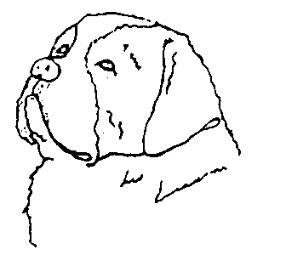
Companion_____ or Show Prospect_____
Do markings make a difference?______

